1. **INTRODUCTION OF PROJECT**

**1.1INTRODUCTION**

The project entitled “**FACULTY INFORMATION SYSTEM**” is software developed for established in computer store. This software enables you to manage faculty record. This project is developed to manage all operations of the faculty. It will have the entire basic module to manage the operations related to faculty .This application would be facilitating the Faculty information System to:-

1. Work is done using computer.
2. New record can be easily added.
3. Can view all detail of faculty operations. (Quick Access).
4. Administration role is there for maintaining records.
5. Provide the security from the un-authentication user.
6. User friendly.
7. Easy to use.

**Various modules**

* **Admin login**: First Administrator will enable the application by putting the security key. This key provides the security from the unauthorized users.
* **Information**: In this menu, the whole detail about faculty members take place such as name of faulty member, address, contact number etc.
* **Profile**: In this menu, we have home sub option and when we click on this we directly go to the faculty information window.

By this project we have tried to give the practical shape to the computerized “**FACULTYINFORMATIONSYSTEM**”. The language (Advance java) used in the creation of this project, proved to be very useful and efficient in event handling. It has buttons and Text fields, which make it more dominating over other packages and languages. Through this project we have tried our best to include all the possible aspects of “**FACULITYINFORMATIONSYSTEM**” to overcome the existing manual system as regards its speed, efficiency and accuracy.

“**FACULTYINFORMATIONSYSTEM**” For Computer Store is asoftware application that maintains the records related to faculty members.

* 1. **EXSISTING SYSTEM**

The transactions related to faculty record are maintained manually at present along with maintaining the information of the faculty members. Problems with manual work are following:-

* All work was done with help of paper.
* Time consuming procedure.
* All process done manually.
* It should not provide quick access to the records maintained.
* Edition and deletion of a record was difficult.
* Data cannot accurate and reliable. So their security is also less.
  1. **OBJECTIVE**

The main objective of the application is to automate the existing system, maintain the records of the facultydetails.

Main purpose of the proposed “**FACULTY INFORMATION SYSTEM**” to overcome the drawback of the existing system, we have planned to make the whole operation of faculty System as computerized. The proposed computerized system will help in reducing the establish cost workload and also should be beneficial in speedily search.

With the help of new system, it provides the facilities for modification, deletion, and faster retrieves of the records.

* 1. **SCOPE**

This application can be used by anycomputer store to automate the process of manually maintaining the records related to the subject of faculty members.

Faculty information System is designed to get information about the staff members. It handles all the operations like Add details, Delete detail, Update Detail etc.

**1.5 Developer’s Responsibilities**

To design and develop the proposed system to solve the problem with the existing system, the developer is responsibility for following events:-

* Evaluates the project for feasibility.
* Analyses current system for problems and opportunities.
* Defines requirements for improving the system.
* Defines system interface, flow and procedure.
* Performs interviews and data gathering.
* Design database structure.
* Design to interface of computer system.
* Developing the system.
* Installing the software on the clients system
* Maintaining the system after installing.

**2. FEASIBILITY STUDY**

In feasibility study we analyze our proposed solution for being feasible or not.Under this we take into consideration three types of feasibility studies.

* Operational Feasibility
* Technical Feasibility
* Economic Feasibility

The term “feasibility study” is used as a convenient description for the output for the work done; users of this toolkit should not apply preconceived notions of what a feasibility study consists of. Stated as simply as possible, the work done here must show that the project:

* is in accordance with predetermined needs;
* is the most suitable technical solution to the needs;
* can be implemented within any capacity constraints of the Institution which operates;

**2.1. Technical Feasibility**

Our project “**FACULTYINFORMATIONSYSTEM**” is technical feasible, because in this it is technically feasible to Add Details. If we want to add new entry, we simply open the Add detail window and add it to the database.

**2.2. Operational Feasibility**

The project is also operationally feasible, because in this project we use the GUI(Graphical User Interface) which is easy to use and understand. It also provides the user friendly interface. The user will easily use the system. But user should know about computer, Incase users have no knowledge than training of project should provideto them. In this we use the buttons, textbox, images which is easily understandable for end user.

**2.3. Economical Feasibility**

“Faculty information System” is economically feasible. In this project we use the java language and the for data storage we use the MY SQL 5.1. It is economically feasible because java is aplatform independent so every system has their JVM. MY SQL and Java both are open source, means one should have no need of internet and it is free of cost.

**3. SOFTWAREREQUIREMENTANALYSIS**

The analysis part of designing of the software focuses on the requirement analysis of the software. It is based on studying of what is required from the software, the nature of program to be built, behavior, performance and interface. It is based on studying the existing system.

|  |  |  |  |
| --- | --- | --- | --- |
| **HARDWARE REQUIREMENTS** | | | |
| PROCESSOR | RAM | | DISK SPACE |
| Pentium IV or above version | 512 MB OR Higher | | 500 MB or above |
| **SOFTWARE REQUIREMENTS** | | | |
| OPERATING SYSTEM | | DATABASE | |
| Window-XP, Window7 | | **MY SQL 5.1** | |

Through graphical user interface it is easy to use and any user can understand it easily. GUI provides user friendly environment.

### **INTERFACE**

The Faculty Information System will use the standard input/output devices for a personal computer. This includes the following:

* Keyboard
* Mouse
* Monitor

### 

### **USER INTERFACE**

Table 1: Faculty Information User Interface Screens

|  |  |
| --- | --- |
| SCREEN NAME | DESCRIPTION |
| Login | Log into the system as an Admin. |
| Faculty Information | Starting page include Information, File, Profile. |
| Information | To store a Faculty information. |
| Profile | Show the Home Option. |
|  |  |

**4. DESIGN**

Once the project is properly defined, the Design step begins. This is the prototype phase of the project. Prototype concepts are basic design ideas; the first look at your project's possibilities.This phase diverts focus from the problem domain to the solution domain. It acts as a bridge between the requirement phase and its solution. The design phase focuses on the detailed implementation of the system recommended in the feasibility study.

Systems design is the process or art of defining the architecture, components, modules, interfaces, and data for a system to satisfy specified requirements. One could see it as the application of systems theory to product development. There is some overlap with the disciplines of systems analysis, systems architecture and systems engineering.

**4.1. The External Design**

External design consists of conceiving, planning out and specifying the externally observable characteristics of the software product. These characteristics include user displays or user interface forms and the report formats, external data sources and the functional characteristics, performance requirements etc. External design begins during the analysis phase and continues into the design phase.

**4.2. Physical design**

The physical design relates to the actual input and output processes of the system. This is laid down in terms of how data is input into a system, how it is verified/ authenticated, how it is processed, and how it is displayed as output. Physical design, in this context, does not refer to the tangible physical design of an information system. To use an analogy, a personal computer's physical design involves input via a keyboard, processing within the CPU, and output via a monitor etc. It would not concern the actual layout of the tangible hardware, which for a PC would be a monitor, CPU, motherboard, hard drive, modems, video/graphics cards, USB slots, etc.

**4.3. Logical design**

The logical design of a system pertains to an abstract representation of the data flows, inputs and outputs of the system. This is often conducted via modeling, which involves a simplistic (and sometimes graphical) representation of an actual system. In the context of systems design, modeling can undertake the following forms, including:

* Data flow diagrams
* Entity Relationship Diagrams

**4.4. Data Flow Diagrams**

Data Flow Diagramming is a means of representing a system at any level of detail with a graphics network of symbol showing data flows, data processes, and data sources/destination.

Data flow diagram (DFD) uses a number of symbols to represent the systems.

**Terms used in DFD**

* **Process:**A process transforms data values. The lowest level processes are pure functions without side effects. An entire data flow graphics high level process.
* **Data flow:**A data flow connects the outputs of a process to input of another object or process. It represents the intermediate data value within a computation. It is represented by an arrow and labeled with a description of data, usually its name or type.
* **Entities:** An actor is active object that drives the data flow graph by producing or consuming values.
* **Data Store:** A Data store is a time-delayed repository of information, where data is kept temporarily or permanently.

**DFD of Faculty Information System:**

**1.DFD Level (0) :**

User

Data Base

**2. Login Window:**

Data Base

Retrieve

Faculty Information

System

Redirect

Provide Username Invalid Username

and Password and Password.

User

3. Faculty Information System:

Data Base

Retrieve

Redirect

Faculty Information

Redirect

**5. Information:**

Data base

Update Status

Redirect

Faculty Info

Provide Information

**4.5. ENTITY DIAGRAM.**

**4.5.1. Login**

In this Entity Diagram a table name is Login. In this table there is two fields Username and Password. The User name data type is Varchar. In this we use User name and Password Data type is Archery, these are used to login the Project.

Login

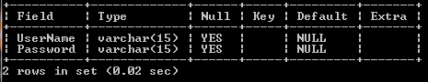

**4.5.2.Faculty Information**

In this Entity diagram, the table name is Faculty info. This table is used to store details of Staff Members. There are twelve fields. Faculty ID is primary key whose data type is integer. Faculty ID ,First Name Last Name, E-Mail, Address, DOB, Gender and Qualification, Contact no,Specailization, Faculty Name.

Faculty Information

**QQ**

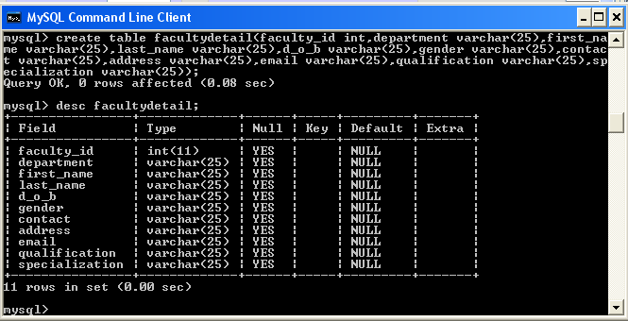

**5. CODING**

The design is complete; most of the major decisions about the system have been made. **After designing the new system, the whole system is required to be converted into computer understanding language.** The goal of the coding phase is to translate the design of the system into code in a given programming language for a given design. The aim of this phase is to implement the design in the best possible manner. The coding phase affects both the testing &maintenance profoundly. A well written code reduce the testing & maintenance effort .since the testing &maintenance cost of software are much higher than coding cost .During the coding focus should be on developing programs that are easy to write

The design must be translated into machine readable form. The code generation step performs this task if the design is performed in a detailed manner, code generation can be accomplished without Much complication, programming language are used for coding & the right programming language is chosen

This is also called programming phase in which the programmer convert the program specification into computer instruction which be refer as programs. The program coordinates the data movements & controls the entire process in a system. It is generally felt that the program must be modular in nature. This helps in fast development, maintenance & future change, if required.

**LANGUAGE**

Java language is used for coding in this project. /*

* To change this template, choose Tools | Templates

* and open the template in the editor.

*/

package facultyinformationsystem;

/**

*

* @author Administrator

*/

public class Login extends javax.swing.JFrame {

/**

* Creates new form Login

*/

public Login() {

initComponents();

}

/**

* This method is called from within the constructor to initialize the form.

* WARNING: Do NOT modify this code. The content of this method is always

* regenerated by the Form Editor.

*/

@SuppressWarnings("unchecked")

// <editor-fold defaultstate="collapsed" desc="Generated Code">

private void initComponents() {

jPanel1 = new javax.swing.JPanel();

jLabel2 = new javax.swing.JLabel();

btnReset = new javax.swing.JButton();

txtUsername = new javax.swing.JTextField();

txtPassword = new javax.swing.JPasswordField();

btnLogin = new javax.swing.JButton();

jLabel1 = new javax.swing.JLabel();

lblWarning = new javax.swing.JLabel();

setDefaultCloseOperation(javax.swing.WindowConstants.EXIT_ON_CLOSE);

jLabel2.setText("Password");

btnReset.setText("Reset");

btnReset.addActionListener(new java.awt.event.ActionListener() {

public void actionPerformed(java.awt.event.ActionEvent evt) {

btnResetActionPerformed(evt);

}

});

txtUsername.addActionListener(new java.awt.event.ActionListener() {

public void actionPerformed(java.awt.event.ActionEvent evt) {

txtUsernameActionPerformed(evt);

}

});

txtPassword.addActionListener(new java.awt.event.ActionListener() {

public void actionPerformed(java.awt.event.ActionEvent evt) {

txtPasswordActionPerformed(evt);

}

});

btnLogin.setText("Login");

btnLogin.addActionListener(new java.awt.event.ActionListener() {

public void actionPerformed(java.awt.event.ActionEvent evt) {

btnLoginActionPerformed(evt);

}

});

jLabel1.setText("Username");

javax.swing.GroupLayout jPanel1Layout = new javax.swing.GroupLayout(jPanel1);

jPanel1.setLayout(jPanel1Layout);

jPanel1Layout.setHorizontalGroup(

jPanel1Layout.createParallelGroup(javax.swing.GroupLayout.Alignment.LEADING)

.addGroup(jPanel1Layout.createSequentialGroup()

.addContainerGap()

.addGroup(jPanel1Layout.createParallelGroup(javax.swing.GroupLayout.Alignment.LEADING)

.addGroup(jPanel1Layout.createParallelGroup(javax.swing.GroupLayout.Alignment.TRAILING)

.addComponent(jLabel2)

.addComponent(jLabel1))

.addGroup(jPanel1Layout.createSequentialGroup()

.addGap(2, 2, 2)

.addComponent(btnReset)))

.addGap(47, 47, 47)

.addGroup(jPanel1Layout.createParallelGroup(javax.swing.GroupLayout.Alignment.LEADING)

.addComponent(btnLogin)

.addComponent(txtUsername, javax.swing.GroupLayout.PREFERRED_SIZE, 100, javax.swing.GroupLayout.PREFERRED_SIZE)

.addComponent(txtPassword, javax.swing.GroupLayout.PREFERRED_SIZE, 100, javax.swing.GroupLayout.PREFERRED_SIZE))

.addContainerGap(20, Short.MAX_VALUE))

.addGroup(javax.swing.GroupLayout.Alignment.TRAILING, jPanel1Layout.createSequentialGroup()

.addComponent(lblWarning, javax.swing.GroupLayout.DEFAULT_SIZE, javax.swing.GroupLayout.DEFAULT_SIZE, Short.MAX_VALUE)

.addContainerGap())

);

jPanel1Layout.setVerticalGroup(

jPanel1Layout.createParallelGroup(javax.swing.GroupLayout.Alignment.LEADING)

.addGroup(jPanel1Layout.createSequentialGroup()

.addContainerGap()

.addGroup(jPanel1Layout.createParallelGroup(javax.swing.GroupLayout.Alignment.LEADING)

.addComponent(jLabel1)

.addComponent(txtUsername, javax.swing.GroupLayout.PREFERRED_SIZE, 20, javax.swing.GroupLayout.PREFERRED_SIZE))

.addGap(50, 50, 50)

.addGroup(jPanel1Layout.createParallelGroup(javax.swing.GroupLayout.Alignment.BASELINE)

.addComponent(jLabel2)

.addComponent(txtPassword, javax.swing.GroupLayout.PREFERRED_SIZE, javax.swing.GroupLayout.DEFAULT_SIZE, javax.swing.GroupLayout.PREFERRED_SIZE))

.addGap(46, 46, 46)

.addGroup(jPanel1Layout.createParallelGroup(javax.swing.GroupLayout.Alignment.BASELINE)

.addComponent(btnLogin)

.addComponent(btnReset))

.addPreferredGap(javax.swing.LayoutStyle.ComponentPlacement.RELATED, 28, Short.MAX_VALUE)

.addComponent(lblWarning, javax.swing.GroupLayout.PREFERRED_SIZE, 24, javax.swing.GroupLayout.PREFERRED_SIZE)

.addGap(26, 26, 26))

);

javax.swing.GroupLayout layout = new javax.swing.GroupLayout(getContentPane());

getContentPane().setLayout(layout);

layout.setHorizontalGroup(

layout.createParallelGroup(javax.swing.GroupLayout.Alignment.LEADING)

.addGroup(layout.createSequentialGroup()

.addGap(26, 26, 26)

.addComponent(jPanel1, javax.swing.GroupLayout.PREFERRED_SIZE, javax.swing.GroupLayout.DEFAULT_SIZE, javax.swing.GroupLayout.PREFERRED_SIZE)

.addContainerGap(47, Short.MAX_VALUE))

);

layout.setVerticalGroup(

layout.createParallelGroup(javax.swing.GroupLayout.Alignment.LEADING)

.addGroup(layout.createSequentialGroup()

.addGap(21, 21, 21)

.addComponent(jPanel1, javax.swing.GroupLayout.PREFERRED_SIZE, javax.swing.GroupLayout.DEFAULT_SIZE, javax.swing.GroupLayout.PREFERRED_SIZE)

.addContainerGap(31, Short.MAX_VALUE))

);

pack();

}// </editor-fold>

private void btnResetActionPerformed(java.awt.event.ActionEvent evt) {

// TODO add your handling code here:

txtUsername.setText("");

txtPassword.setText("");

}

private void btnLoginActionPerformed(java.awt.event.ActionEvent evt) {

// TODO add your handling code here:

String un = txtUsername.getText();

String psw = txtPassword.getText();

if(un.equals("admin") && psw.equals("admin"))

{

MainFrame obj = new MainFrame();

}

else

{

lblWarning.setText("Please provide valid username or password");

}

}

private void txtPasswordActionPerformed(java.awt.event.ActionEvent evt) {

// TODO add your handling code here:

}

private void txtUsernameActionPerformed(java.awt.event.ActionEvent evt) {

// TODO add your handling code here:

}

/**

* @param args the command line arguments

*/

public static void main(String args[]) {

/* Set the Nimbus look and feel */

//<editor-fold defaultstate="collapsed" desc=" Look and feel setting code (optional) ">

/* If Nimbus (introduced in Java SE 6) is not available, stay with the default look and feel.

* For details see http://download.oracle.com/javase/tutorial/uiswing/lookandfeel/plaf.html

*/

try {

for (javax.swing.UIManager.LookAndFeelInfo info : javax.swing.UIManager.getInstalledLookAndFeels()) {

if ("Nimbus".equals(info.getName())) {

javax.swing.UIManager.setLookAndFeel(info.getClassName());

break;

}

}

} catch (ClassNotFoundException ex) {

java.util.logging.Logger.getLogger(Login.class.getName()).log(java.util.logging.Level.SEVERE, null, ex);

} catch (InstantiationException ex) {

java.util.logging.Logger.getLogger(Login.class.getName()).log(java.util.logging.Level.SEVERE, null, ex);

} catch (IllegalAccessException ex) {

java.util.logging.Logger.getLogger(Login.class.getName()).log(java.util.logging.Level.SEVERE, null, ex);

} catch (javax.swing.UnsupportedLookAndFeelException ex) {

java.util.logging.Logger.getLogger(Login.class.getName()).log(java.util.logging.Level.SEVERE, null, ex);

}

//</editor-fold>

/* Create and display the form */

java.awt.EventQueue.invokeLater(new Runnable() {

public void run() {

new Login().setVisible(true);

}

});

}

// Variables declaration - do not modify

private javax.swing.JButton btnLogin;

private javax.swing.JButton btnReset;

private javax.swing.JLabel jLabel1;

private javax.swing.JLabel jLabel2;

private javax.swing.JPanel jPanel1;

private javax.swing.JLabel lblWarning;

private javax.swing.JPasswordField txtPassword;

private javax.swing.JTextField txtUsername;

// End of variables declaration

}

/*

* To change this template, choose Tools | Templates

* and open the template in the editor.

*/

package facultyinformationsystem;

import java.awt.Container;

import java.awt.Toolkit;

/**

*

* @author Administrator

*/

public class MainFrame extends javax.swing.JFrame {

/**

* Creates new form MainFrame

*/

Container c=null;

public MainFrame() {

initComponents();

setVisible(true);

setSize(Toolkit.getDefaultToolkit().getScreenSize());

c=getContentPane();

}

/**

* This method is called from within the constructor to initialize the form.

* WARNING: Do NOT modify this code. The content of this method is always

* regenerated by the Form Editor.

*/

@SuppressWarnings("unchecked")

// <editor-fold defaultstate="collapsed" desc="Generated Code">

private void initComponents() {

jMenuBar1 = new javax.swing.JMenuBar();

jMenu1 = new javax.swing.JMenu();

menuItemFacultyDetail = new javax.swing.JMenu();

jMenuItem1 = new javax.swing.JMenuItem();

setDefaultCloseOperation(javax.swing.WindowConstants.EXIT_ON_CLOSE);

jMenu1.setText("File");

jMenuBar1.add(jMenu1);

menuItemFacultyDetail.setText("Faculty");

jMenuItem1.setText("Faculty Detail");

jMenuItem1.addActionListener(new java.awt.event.ActionListener() {

public void actionPerformed(java.awt.event.ActionEvent evt) {

jMenuItem1ActionPerformed(evt);

}

});

menuItemFacultyDetail.add(jMenuItem1);

jMenuBar1.add(menuItemFacultyDetail);

setJMenuBar(jMenuBar1);

javax.swing.GroupLayout layout = new javax.swing.GroupLayout(getContentPane());

getContentPane().setLayout(layout);

layout.setHorizontalGroup(

layout.createParallelGroup(javax.swing.GroupLayout.Alignment.LEADING)

.addGap(0, 400, Short.MAX_VALUE)

);

layout.setVerticalGroup(

layout.createParallelGroup(javax.swing.GroupLayout.Alignment.LEADING)

.addGap(0, 279, Short.MAX_VALUE)

);

pack();

}// </editor-fold>

private void jMenuItem1ActionPerformed(java.awt.event.ActionEvent evt) {

// TODO add your handling code here:

c.removeAll();

FacultyDetail obj = new FacultyDetail();

obj.setBounds(50, 50, 1000, 700);

c.add(obj);

obj.setVisible(false);

obj.setVisible(true);

}

/**

* @param args the command line arguments

*/

public static void main(String args[]) {

/* Set the Nimbus look and feel */

//<editor-fold defaultstate="collapsed" desc=" Look and feel setting code (optional) ">

/* If Nimbus (introduced in Java SE 6) is not available, stay with the default look and feel.

* For details see http://download.oracle.com/javase/tutorial/uiswing/lookandfeel/plaf.html

*/

try {

for (javax.swing.UIManager.LookAndFeelInfo info : javax.swing.UIManager.getInstalledLookAndFeels()) {

if ("Nimbus".equals(info.getName())) {

javax.swing.UIManager.setLookAndFeel(info.getClassName());

break;

}

}

} catch (ClassNotFoundException ex) {

java.util.logging.Logger.getLogger(MainFrame.class.getName()).log(java.util.logging.Level.SEVERE, null, ex);

} catch (InstantiationException ex) {

java.util.logging.Logger.getLogger(MainFrame.class.getName()).log(java.util.logging.Level.SEVERE, null, ex);

} catch (IllegalAccessException ex) {

java.util.logging.Logger.getLogger(MainFrame.class.getName()).log(java.util.logging.Level.SEVERE, null, ex);

} catch (javax.swing.UnsupportedLookAndFeelException ex) {

java.util.logging.Logger.getLogger(MainFrame.class.getName()).log(java.util.logging.Level.SEVERE, null, ex);

}

//</editor-fold>

/* Create and display the form */

java.awt.EventQueue.invokeLater(new Runnable() {

public void run() {

new MainFrame().setVisible(true);

}

});

}

// Variables declaration - do not modify

private javax.swing.JMenu jMenu1;

private javax.swing.JMenuBar jMenuBar1;

private javax.swing.JMenuItem jMenuItem1;

private javax.swing.JMenu menuItemFacultyDetail;

// End of variables declaration

}

/*

* To change this template, choose Tools | Templates

* and open the template in the editor.

*/

package facultyinformationsystem;

/**

*

* @author Administrator

*/

public class FacultyDetail extends javax.swing.JPanel {

/**

* Creates new form FacultyDetail

*/

public FacultyDetail() {

initComponents();

}

/**

* This method is called from within the constructor to initialize the form.

* WARNING: Do NOT modify this code. The content of this method is always

* regenerated by the Form Editor.

*/

@SuppressWarnings("unchecked")

// <editor-fold defaultstate="collapsed" desc="Generated Code">

private void initComponents() {

jPanel1 = new javax.swing.JPanel();

jLabel2 = new javax.swing.JLabel();

jLabel4 = new javax.swing.JLabel();

txtFirstname = new javax.swing.JTextField();

txtLastName = new javax.swing.JTextField();

jLabel6 = new javax.swing.JLabel();

txtGender = new javax.swing.JTextField();

jLabel5 = new javax.swing.JLabel();

txtDepartment = new javax.swing.JTextField();

txtDOB = new javax.swing.JTextField();

txtFacultyID = new javax.swing.JTextField();

jLabel1 = new javax.swing.JLabel();

jLabel3 = new javax.swing.JLabel();

jPanel2 = new javax.swing.JPanel();

txtEmail = new javax.swing.JTextField();

jLabel7 = new javax.swing.JLabel();

txtSpcialization = new javax.swing.JTextField();

jLabel11 = new javax.swing.JLabel();

jLabel9 = new javax.swing.JLabel();

txtAddress = new javax.swing.JTextField();

jLabel8 = new javax.swing.JLabel();

txtQualification = new javax.swing.JTextField();

jLabel10 = new javax.swing.JLabel();

txtContactNo = new javax.swing.JTextField();

jPanel3 = new javax.swing.JPanel();

txtfirst = new javax.swing.JButton();

btnSAVE = new javax.swing.JButton();

btnLAST = new javax.swing.JButton();

btnAdd = new javax.swing.JButton();

btnPREVIOUS = new javax.swing.JButton();

btnUPDATE = new javax.swing.JButton();

btnNEXT = new javax.swing.JButton();

jScrollPane1 = new javax.swing.JScrollPane();

jTable1 = new javax.swing.JTable();

jPanel1.setBackground(new java.awt.Color(204, 204, 255));

jLabel2.setText("Department");

jLabel4.setText("Last Name");

jLabel6.setText("Gender");

jLabel5.setText("D.O.B.");

jLabel1.setText("FacultyID");

jLabel3.setText("First Name");

javax.swing.GroupLayout jPanel1Layout = new javax.swing.GroupLayout(jPanel1);

jPanel1.setLayout(jPanel1Layout);

jPanel1Layout.setHorizontalGroup(

jPanel1Layout.createParallelGroup(javax.swing.GroupLayout.Alignment.LEADING)

.addGroup(jPanel1Layout.createSequentialGroup()

.addContainerGap()

.addGroup(jPanel1Layout.createParallelGroup(javax.swing.GroupLayout.Alignment.LEADING)

.addComponent(jLabel6)

.addGroup(jPanel1Layout.createParallelGroup(javax.swing.GroupLayout.Alignment.LEADING)

.addGroup(javax.swing.GroupLayout.Alignment.TRAILING, jPanel1Layout.createSequentialGroup()

.addComponent(jLabel5, javax.swing.GroupLayout.PREFERRED_SIZE, 35, javax.swing.GroupLayout.PREFERRED_SIZE)

.addGap(57, 57, 57))

.addComponent(jLabel2, javax.swing.GroupLayout.PREFERRED_SIZE, 92, javax.swing.GroupLayout.PREFERRED_SIZE)

.addComponent(jLabel3)

.addComponent(jLabel1, javax.swing.GroupLayout.PREFERRED_SIZE, 56, javax.swing.GroupLayout.PREFERRED_SIZE)

.addComponent(jLabel4)))

.addPreferredGap(javax.swing.LayoutStyle.ComponentPlacement.RELATED)

.addGroup(jPanel1Layout.createParallelGroup(javax.swing.GroupLayout.Alignment.LEADING, false)

.addComponent(txtFacultyID)

.addComponent(txtFirstname)

.addComponent(txtLastName)

.addComponent(txtDepartment, javax.swing.GroupLayout.PREFERRED_SIZE, 68, javax.swing.GroupLayout.PREFERRED_SIZE)

.addComponent(txtDOB)

.addComponent(txtGender, javax.swing.GroupLayout.Alignment.TRAILING, javax.swing.GroupLayout.PREFERRED_SIZE, 69, javax.swing.GroupLayout.PREFERRED_SIZE))

.addContainerGap())

);

jPanel1Layout.setVerticalGroup(

jPanel1Layout.createParallelGroup(javax.swing.GroupLayout.Alignment.LEADING)

.addGroup(jPanel1Layout.createSequentialGroup()

.addContainerGap()

.addGroup(jPanel1Layout.createParallelGroup(javax.swing.GroupLayout.Alignment.LEADING)

.addComponent(jLabel1, javax.swing.GroupLayout.PREFERRED_SIZE, 25, javax.swing.GroupLayout.PREFERRED_SIZE)

.addComponent(txtFacultyID, javax.swing.GroupLayout.PREFERRED_SIZE, javax.swing.GroupLayout.DEFAULT_SIZE, javax.swing.GroupLayout.PREFERRED_SIZE))

.addPreferredGap(javax.swing.LayoutStyle.ComponentPlacement.RELATED)

.addGroup(jPanel1Layout.createParallelGroup(javax.swing.GroupLayout.Alignment.BASELINE)

.addComponent(jLabel2, javax.swing.GroupLayout.PREFERRED_SIZE, 32, javax.swing.GroupLayout.PREFERRED_SIZE)

.addComponent(txtDepartment, javax.swing.GroupLayout.PREFERRED_SIZE, javax.swing.GroupLayout.DEFAULT_SIZE, javax.swing.GroupLayout.PREFERRED_SIZE))

.addGroup(jPanel1Layout.createParallelGroup(javax.swing.GroupLayout.Alignment.LEADING, false)

.addGroup(jPanel1Layout.createSequentialGroup()

.addGap(17, 17, 17)

.addComponent(txtFirstname, javax.swing.GroupLayout.PREFERRED_SIZE, javax.swing.GroupLayout.DEFAULT_SIZE, javax.swing.GroupLayout.PREFERRED_SIZE))

.addGroup(jPanel1Layout.createSequentialGroup()

.addPreferredGap(javax.swing.LayoutStyle.ComponentPlacement.UNRELATED)

.addComponent(jLabel3, javax.swing.GroupLayout.PREFERRED_SIZE, 26, javax.swing.GroupLayout.PREFERRED_SIZE)))

.addGap(18, 18, 18)

.addGroup(jPanel1Layout.createParallelGroup(javax.swing.GroupLayout.Alignment.BASELINE)

.addComponent(txtLastName, javax.swing.GroupLayout.PREFERRED_SIZE, javax.swing.GroupLayout.DEFAULT_SIZE, javax.swing.GroupLayout.PREFERRED_SIZE)

.addComponent(jLabel4, javax.swing.GroupLayout.PREFERRED_SIZE, 20, javax.swing.GroupLayout.PREFERRED_SIZE))

.addGap(17, 17, 17)

.addGroup(jPanel1Layout.createParallelGroup(javax.swing.GroupLayout.Alignment.BASELINE)

.addComponent(jLabel5, javax.swing.GroupLayout.PREFERRED_SIZE, 27, javax.swing.GroupLayout.PREFERRED_SIZE)

.addComponent(txtDOB, javax.swing.GroupLayout.PREFERRED_SIZE, javax.swing.GroupLayout.DEFAULT_SIZE, javax.swing.GroupLayout.PREFERRED_SIZE))

.addPreferredGap(javax.swing.LayoutStyle.ComponentPlacement.UNRELATED)

.addGroup(jPanel1Layout.createParallelGroup(javax.swing.GroupLayout.Alignment.LEADING, false)

.addComponent(txtGender)

.addComponent(jLabel6, javax.swing.GroupLayout.DEFAULT_SIZE, javax.swing.GroupLayout.DEFAULT_SIZE, Short.MAX_VALUE))

.addContainerGap(63, Short.MAX_VALUE))

);

jPanel2.setBackground(new java.awt.Color(204, 204, 255));

jLabel7.setText("Contact No.");

jLabel11.setText("Spcialization");

jLabel9.setText("E-mail");

jLabel8.setText("Address");

jLabel10.setText("Qualification");

javax.swing.GroupLayout jPanel2Layout = new javax.swing.GroupLayout(jPanel2);

jPanel2.setLayout(jPanel2Layout);

jPanel2Layout.setHorizontalGroup(

jPanel2Layout.createParallelGroup(javax.swing.GroupLayout.Alignment.LEADING)

.addGroup(jPanel2Layout.createSequentialGroup()

.addContainerGap()

.addGroup(jPanel2Layout.createParallelGroup(javax.swing.GroupLayout.Alignment.LEADING)

.addGroup(jPanel2Layout.createParallelGroup(javax.swing.GroupLayout.Alignment.LEADING)

.addGroup(jPanel2Layout.createSequentialGroup()

.addComponent(jLabel7)

.addGap(58, 58, 58))

.addGroup(javax.swing.GroupLayout.Alignment.TRAILING, jPanel2Layout.createSequentialGroup()

.addComponent(jLabel10, javax.swing.GroupLayout.PREFERRED_SIZE, 84, javax.swing.GroupLayout.PREFERRED_SIZE)

.addGap(32, 32, 32)))

.addGroup(jPanel2Layout.createSequentialGroup()

.addComponent(jLabel9, javax.swing.GroupLayout.PREFERRED_SIZE, 39, javax.swing.GroupLayout.PREFERRED_SIZE)

.addGap(77, 77, 77))

.addComponent(jLabel8)

.addComponent(jLabel11))

.addGroup(jPanel2Layout.createParallelGroup(javax.swing.GroupLayout.Alignment.LEADING)

.addComponent(txtAddress, javax.swing.GroupLayout.PREFERRED_SIZE, 69, javax.swing.GroupLayout.PREFERRED_SIZE)

.addComponent(txtEmail, javax.swing.GroupLayout.PREFERRED_SIZE, 69, javax.swing.GroupLayout.PREFERRED_SIZE)

.addComponent(txtQualification, javax.swing.GroupLayout.PREFERRED_SIZE, 69, javax.swing.GroupLayout.PREFERRED_SIZE)

.addComponent(txtContactNo, javax.swing.GroupLayout.PREFERRED_SIZE, 69, javax.swing.GroupLayout.PREFERRED_SIZE)

.addComponent(txtSpcialization, javax.swing.GroupLayout.PREFERRED_SIZE, 69, javax.swing.GroupLayout.PREFERRED_SIZE))

.addGap(26, 26, 26))

);

jPanel2Layout.setVerticalGroup(

jPanel2Layout.createParallelGroup(javax.swing.GroupLayout.Alignment.LEADING)

.addGroup(jPanel2Layout.createSequentialGroup()

.addContainerGap()

.addGroup(jPanel2Layout.createParallelGroup(javax.swing.GroupLayout.Alignment.BASELINE)

.addComponent(jLabel7)

.addComponent(txtContactNo, javax.swing.GroupLayout.PREFERRED_SIZE, javax.swing.GroupLayout.DEFAULT_SIZE, javax.swing.GroupLayout.PREFERRED_SIZE))

.addGap(39, 39, 39)

.addGroup(jPanel2Layout.createParallelGroup(javax.swing.GroupLayout.Alignment.BASELINE)

.addComponent(jLabel8)

.addComponent(txtAddress, javax.swing.GroupLayout.PREFERRED_SIZE, javax.swing.GroupLayout.DEFAULT_SIZE, javax.swing.GroupLayout.PREFERRED_SIZE))

.addGap(23, 23, 23)

.addGroup(jPanel2Layout.createParallelGroup(javax.swing.GroupLayout.Alignment.BASELINE)

.addComponent(jLabel9, javax.swing.GroupLayout.PREFERRED_SIZE, 36, javax.swing.GroupLayout.PREFERRED_SIZE)

.addComponent(txtEmail, javax.swing.GroupLayout.PREFERRED_SIZE, javax.swing.GroupLayout.DEFAULT_SIZE, javax.swing.GroupLayout.PREFERRED_SIZE))

.addGap(18, 18, 18)

.addGroup(jPanel2Layout.createParallelGroup(javax.swing.GroupLayout.Alignment.TRAILING)

.addComponent(jLabel10, javax.swing.GroupLayout.PREFERRED_SIZE, 28, javax.swing.GroupLayout.PREFERRED_SIZE)

.addComponent(txtQualification, javax.swing.GroupLayout.PREFERRED_SIZE, javax.swing.GroupLayout.DEFAULT_SIZE, javax.swing.GroupLayout.PREFERRED_SIZE))

.addGap(18, 18, 18)

.addGroup(jPanel2Layout.createParallelGroup(javax.swing.GroupLayout.Alignment.TRAILING)

.addComponent(jLabel11, javax.swing.GroupLayout.PREFERRED_SIZE, 28, javax.swing.GroupLayout.PREFERRED_SIZE)

.addComponent(txtSpcialization, javax.swing.GroupLayout.PREFERRED_SIZE, javax.swing.GroupLayout.DEFAULT_SIZE, javax.swing.GroupLayout.PREFERRED_SIZE))

.addContainerGap(javax.swing.GroupLayout.DEFAULT_SIZE, Short.MAX_VALUE))

);

jPanel3.setBackground(new java.awt.Color(255, 204, 204));

txtfirst.setText("First");

btnSAVE.setText("Save");

btnSAVE.addActionListener(new java.awt.event.ActionListener() {

public void actionPerformed(java.awt.event.ActionEvent evt) {

btnSAVEActionPerformed(evt);

}

});

btnLAST.setText("Last");

btnAdd.setBackground(new java.awt.Color(255, 204, 204));

btnAdd.setText("Add");

btnAdd.addActionListener(new java.awt.event.ActionListener() {

public void actionPerformed(java.awt.event.ActionEvent evt) {

btnAddActionPerformed(evt);

}

});

btnPREVIOUS.setText("Previous");

btnUPDATE.setText("Update");

btnNEXT.setText("Next");

btnNEXT.addActionListener(new java.awt.event.ActionListener() {

public void actionPerformed(java.awt.event.ActionEvent evt) {

btnNEXTActionPerformed(evt);

}

});

javax.swing.GroupLayout jPanel3Layout = new javax.swing.GroupLayout(jPanel3);

jPanel3.setLayout(jPanel3Layout);

jPanel3Layout.setHorizontalGroup(

jPanel3Layout.createParallelGroup(javax.swing.GroupLayout.Alignment.LEADING)

.addGroup(jPanel3Layout.createSequentialGroup()

.addContainerGap()

.addGroup(jPanel3Layout.createParallelGroup(javax.swing.GroupLayout.Alignment.LEADING)

.addGroup(jPanel3Layout.createSequentialGroup()

.addGroup(jPanel3Layout.createParallelGroup(javax.swing.GroupLayout.Alignment.LEADING)

.addComponent(btnAdd, javax.swing.GroupLayout.PREFERRED_SIZE, 59, javax.swing.GroupLayout.PREFERRED_SIZE)

.addComponent(btnSAVE))

.addGap(37, 37, 37)

.addGroup(jPanel3Layout.createParallelGroup(javax.swing.GroupLayout.Alignment.LEADING)

.addGroup(jPanel3Layout.createSequentialGroup()

.addComponent(txtfirst)

.addGap(18, 18, 18)

.addComponent(btnLAST))

.addGroup(jPanel3Layout.createSequentialGroup()

.addComponent(btnNEXT)

.addGap(18, 18, 18)

.addComponent(btnPREVIOUS))))

.addGroup(jPanel3Layout.createSequentialGroup()

.addGap(272, 272, 272)

.addComponent(btnUPDATE)))

.addContainerGap())

);

jPanel3Layout.setVerticalGroup(

jPanel3Layout.createParallelGroup(javax.swing.GroupLayout.Alignment.LEADING)

.addGroup(jPanel3Layout.createSequentialGroup()

.addContainerGap()

.addGroup(jPanel3Layout.createParallelGroup(javax.swing.GroupLayout.Alignment.LEADING)

.addComponent(btnAdd)

.addGroup(jPanel3Layout.createParallelGroup(javax.swing.GroupLayout.Alignment.BASELINE)

.addComponent(btnLAST, javax.swing.GroupLayout.DEFAULT_SIZE, javax.swing.GroupLayout.DEFAULT_SIZE, Short.MAX_VALUE)

.addComponent(txtfirst, javax.swing.GroupLayout.DEFAULT_SIZE, javax.swing.GroupLayout.DEFAULT_SIZE, Short.MAX_VALUE)

.addComponent(btnUPDATE, javax.swing.GroupLayout.DEFAULT_SIZE, javax.swing.GroupLayout.DEFAULT_SIZE, Short.MAX_VALUE)))

.addGap(52, 52, 52)

.addGroup(jPanel3Layout.createParallelGroup(javax.swing.GroupLayout.Alignment.BASELINE)

.addComponent(btnSAVE)

.addComponent(btnNEXT)

.addComponent(btnPREVIOUS))

.addContainerGap())

);

jTable1.setModel(new javax.swing.table.DefaultTableModel(

new Object [][] {

{null, null, null, null},

{null, null, null, null},

{null, null, null, null},

{null, null, null, null}

},

new String [] {

"Title 1", "Title 2", "Title 3", "Title 4"

}

));

jScrollPane1.setViewportView(jTable1);

javax.swing.GroupLayout layout = new javax.swing.GroupLayout(this);

this.setLayout(layout);

layout.setHorizontalGroup(

layout.createParallelGroup(javax.swing.GroupLayout.Alignment.LEADING)

.addGroup(layout.createSequentialGroup()

.addGap(67, 67, 67)

.addGroup(layout.createParallelGroup(javax.swing.GroupLayout.Alignment.LEADING)

.addGroup(layout.createSequentialGroup()

.addComponent(jPanel1, javax.swing.GroupLayout.PREFERRED_SIZE, javax.swing.GroupLayout.DEFAULT_SIZE, javax.swing.GroupLayout.PREFERRED_SIZE)

.addGap(29, 29, 29)

.addComponent(jPanel2, javax.swing.GroupLayout.PREFERRED_SIZE, javax.swing.GroupLayout.DEFAULT_SIZE, javax.swing.GroupLayout.PREFERRED_SIZE))

.addGroup(layout.createSequentialGroup()

.addGap(31, 31, 31)

.addComponent(jPanel3, javax.swing.GroupLayout.PREFERRED_SIZE, javax.swing.GroupLayout.DEFAULT_SIZE, javax.swing.GroupLayout.PREFERRED_SIZE)))

.addGap(157, 157, 157)

.addComponent(jScrollPane1, javax.swing.GroupLayout.PREFERRED_SIZE, javax.swing.GroupLayout.DEFAULT_SIZE, javax.swing.GroupLayout.PREFERRED_SIZE)

.addContainerGap(javax.swing.GroupLayout.DEFAULT_SIZE, Short.MAX_VALUE))

);

layout.setVerticalGroup(

layout.createParallelGroup(javax.swing.GroupLayout.Alignment.LEADING)

.addGroup(layout.createSequentialGroup()

.addGap(21, 21, 21)

.addGroup(layout.createParallelGroup(javax.swing.GroupLayout.Alignment.LEADING)

.addGroup(layout.createSequentialGroup()

.addComponent(jScrollPane1, javax.swing.GroupLayout.PREFERRED_SIZE, javax.swing.GroupLayout.DEFAULT_SIZE, javax.swing.GroupLayout.PREFERRED_SIZE)

.addContainerGap(javax.swing.GroupLayout.DEFAULT_SIZE, Short.MAX_VALUE))

.addGroup(layout.createSequentialGroup()

.addGroup(layout.createParallelGroup(javax.swing.GroupLayout.Alignment.LEADING)

.addComponent(jPanel1, javax.swing.GroupLayout.DEFAULT_SIZE, javax.swing.GroupLayout.DEFAULT_SIZE, Short.MAX_VALUE)

.addComponent(jPanel2, javax.swing.GroupLayout.DEFAULT_SIZE, javax.swing.GroupLayout.DEFAULT_SIZE, Short.MAX_VALUE))

.addPreferredGap(javax.swing.LayoutStyle.ComponentPlacement.RELATED)

.addComponent(jPanel3, javax.swing.GroupLayout.DEFAULT_SIZE, javax.swing.GroupLayout.DEFAULT_SIZE, Short.MAX_VALUE)

.addGap(195, 195, 195))))

);

}// </editor-fold>

private void btnSAVEActionPerformed(java.awt.event.ActionEvent evt) {

// TODO add your handling code here:

}

private void btnAddActionPerformed(java.awt.event.ActionEvent evt) {

// TODO add your handling code here:

}

private void btnNEXTActionPerformed(java.awt.event.ActionEvent evt) {

// TODO add your handling code here:

}

// Variables declaration - do not modify

private javax.swing.JButton btnAdd;

private javax.swing.JButton btnLAST;

private javax.swing.JButton btnNEXT;

private javax.swing.JButton btnPREVIOUS;

private javax.swing.JButton btnSAVE;

private javax.swing.JButton btnUPDATE;

private javax.swing.JLabel jLabel1;

private javax.swing.JLabel jLabel10;

private javax.swing.JLabel jLabel11;

private javax.swing.JLabel jLabel2;

private javax.swing.JLabel jLabel3;

private javax.swing.JLabel jLabel4;

private javax.swing.JLabel jLabel5;

private javax.swing.JLabel jLabel6;

private javax.swing.JLabel jLabel7;

private javax.swing.JLabel jLabel8;

private javax.swing.JLabel jLabel9;

private javax.swing.JPanel jPanel1;

private javax.swing.JPanel jPanel2;

private javax.swing.JPanel jPanel3;

private javax.swing.JScrollPane jScrollPane1;

private javax.swing.JTable jTable1;

private javax.swing.JTextField txtAddress;

private javax.swing.JTextField txtContactNo;

private javax.swing.JTextField txtDOB;

private javax.swing.JTextField txtDepartment;

private javax.swing.JTextField txtEmail;

private javax.swing.JTextField txtFacultyID;

private javax.swing.JTextField txtFirstname;

private javax.swing.JTextField txtGender;

private javax.swing.JTextField txtLastName;

private javax.swing.JTextField txtQualification;

private javax.swing.JTextField txtSpcialization;

private javax.swing.JButton txtfirst;

// End of variables declaration

}

**6. TESTING**

Before actually implementing the new system into operation, a test run of the system is done removing all bugs, if any. It is an important phase of a successful system. After codifying the whole program of the system, a test plan should be developed on run on a given set of test data. The output of the test run should match the expected result.

Testing is a process of executing a program with the intent of finding an error. A good test case is on that has high probability of finding an as yet undiscovered error. No program or system is perfect, communication between user and designer is not always clear. The result is error and error. So testing performs a main role in developing software.

In this phase, the system is tested normally programs are written as series of individual modules, these subjects separated& detailed test .The system is then tested as whole .The separated modules are brought together & tested as complete system. The system is tested to ensure that interface between modules work (integration testing) the system work on the intended platform with the expected volume of the data (volume testing) & that the system does what the user require (beta testing). System testing involves testing hardware devices & debugging computer programs, testing information processing procedures.

**The people who are responsible for testing a software application:**

1. Software testing can be conducted by the developers of the system or an independent testing group who are part of the organization that has built the system.
2. Software testing can also be conducted by the client or the ultimate users of the system.
3. The team responsible for the different types of testing needs to be decided upon during the planning stage.
   1. **The various stages in testing**

Software testing is usually performed at different levels of abstraction of the application along the software development process by the builders of the system.

**There are five testing stages**

**6.1.1. Unit testing.**

**6.1.2. Integration testing.**

**6.1.3. System testing.**

**6.1.4. Acceptance testing.**

**6.1.5. Regression testing.**

The objective and the abstraction levels of the application to which these tests are performed are different.

* Unit tests are performed on the smallest individual units of the application. Unit testing uses code and detailed design as an input to check correctness of individual units.
* The integration tests on a group of modules and their interfaces. Integration testing uses the system design and the functional specification document as an input.
* The system tests are for the entire system and the interfacing external systems.System testing uses the overall functionality of the system as given in the functional specifications and software requirements. It also evaluates the non- functional requirements.
* Acceptance testing is the test conducted periodically by client representatives to check if client requirements have been met adequately.
* Regression testing, on the other hand, retests the tested sections of the software to ensure no unintended error has been introduced.

Here is another very important concept of software testing, that is, the test case. Test cases are scenarios that are executed by the testers on the completed application to determine if the application meets a specific requirement. One or more test cases may be required to determine if a requirement is satisfied.

A good test case is one that uncovers errors in a complete manner with minimum time and effort. Considering the earlier example of the completed house, the analysis, 'check if the colorof chimney is red' is a test case. If for the same example, when the test case is written as 'check if the door does not open with a wrong key', becomes a negative test case. Hence, we learn that a test case is a statement specifying an input, an action, or an event and expects a specific response after execution.

**6.2. TEST CASES**

**Login**

|  |  |  |  |
| --- | --- | --- | --- |
| **Case No.** | **Security Key** | **Valid/Invalid** | **Response** |
| 1 | admin | Valid | Authentic |
| 2 |  | Invalid, because Security Key field is empty | Nothing |
| 3 | ABC | Invalid, Because Security Key is incorrect | Show message  “Invalid username or password” |

**ADD Faculty Information**

|  |  |  |  |
| --- | --- | --- | --- |
| **Case No.** | **Field Values** | **Valid/Invalid** | **Response** |
| 1 | Faculty ID=”101”  Department=Computer Application  First Name=Manpreet  Last Name=Kaur  D_O_B=19-8-1996  Gender=Female  Contact No=01679688567  Address =K.CRoadBarnala  EMail=Meetj67@gmail.com  Qualification=BCA  Specilization= | Valid | Save Record into database. |
| 2 | Faculty ID=  Department=  First Name=  First Name=  DOB=  Gender=  Address =  Email=Meetj67@gmil.com  Contant No.=  Qualification=  E-mail=”    Specilization= | Invalid | Record is not saved into database. |

**7. IMPLEMENTATION AND POST IMPLEMENTATION**

A crucial phase in the system development life cycle is the successful implementation of the new designed system implementation. It includes all those activities that take place to convert from the old system to the new system. The new system is here replacing an existing manual system. The proper implementation become necessary so that a reliable system based on the requirement of the organization can be provided. Successful implementation guarantees improvement in the organization working.

Finally the actual implementation requires launching of the web site and fulfills the required formalities with the concerned authority and feeding of all the information required in the database. Thus, implementation is vital step in ensuring the success of new system. Even well-designed system can fail if it is not properly implemented.

**Implementation Activities**

* Acquisition of hardware, software &services
* Software development or modification
* End user training
* System documentation & installing

1. **SNAPSHOTS**

**Login Frame:**

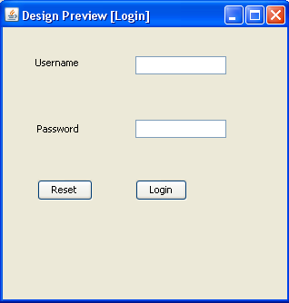

**Description:** It is the LOGIN WINDOW of Faculty Information System. In this, the admin can enter the user name and password. If the user name is correct then redirect to main frame otherwise show the error message that user name or password is Invalid.

**Main Frame**

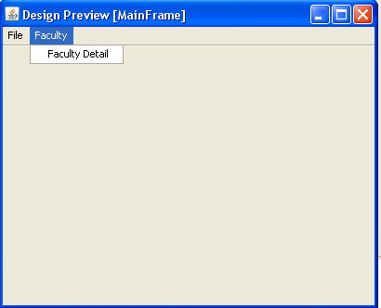

**Description:**After the valid user name or password admin enter the faculty

Information window and select Information menu and then their sub menu Faculty info. Then faculty info panel can be show to the admin..

**Save:**

**Description:**When the user can fill the entire field they can click on the save button and they can show the message Record is added successfully.

**Insert**:

S

**Description:**when the admin can insert the new record in faculty info table they can simply click on the insert button then the entire field can empty and admin can insert the new record.

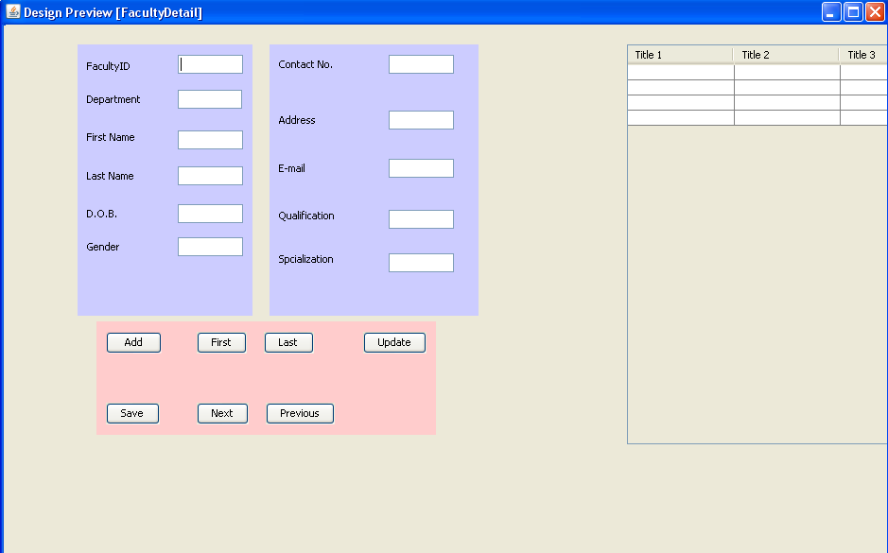

**Exit:**

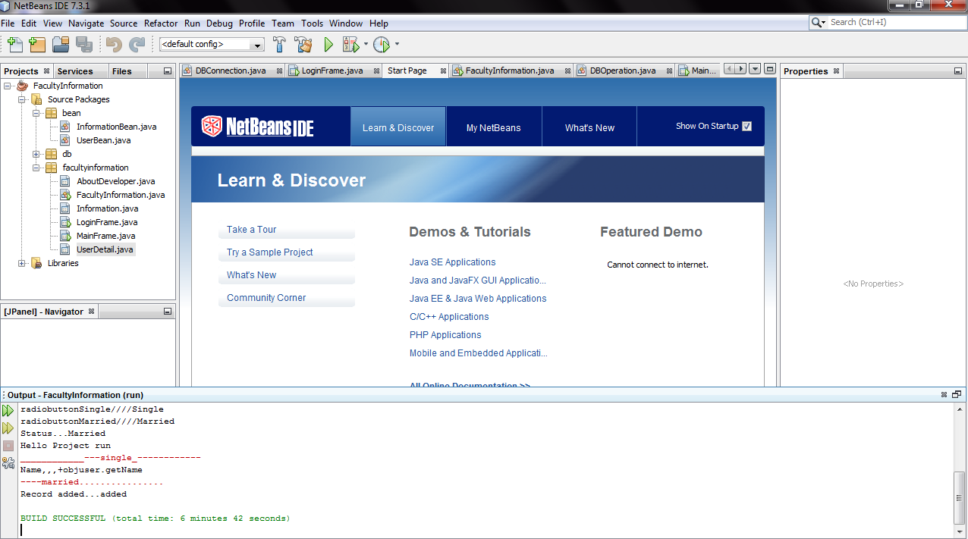

**Description:** When user want to stop the running project. Then, they can click on exit button and they run out from the project.

**First Record:**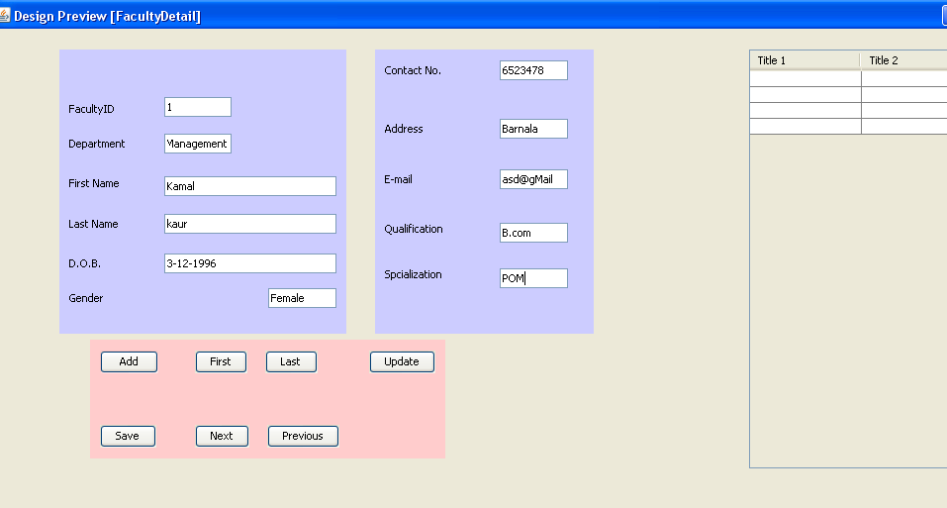

**Description:** It shows the first record of the faculty info. When admin wants to see first record of faculty, then admin can click to the first button and shows the first record of table.

**Last Record:** 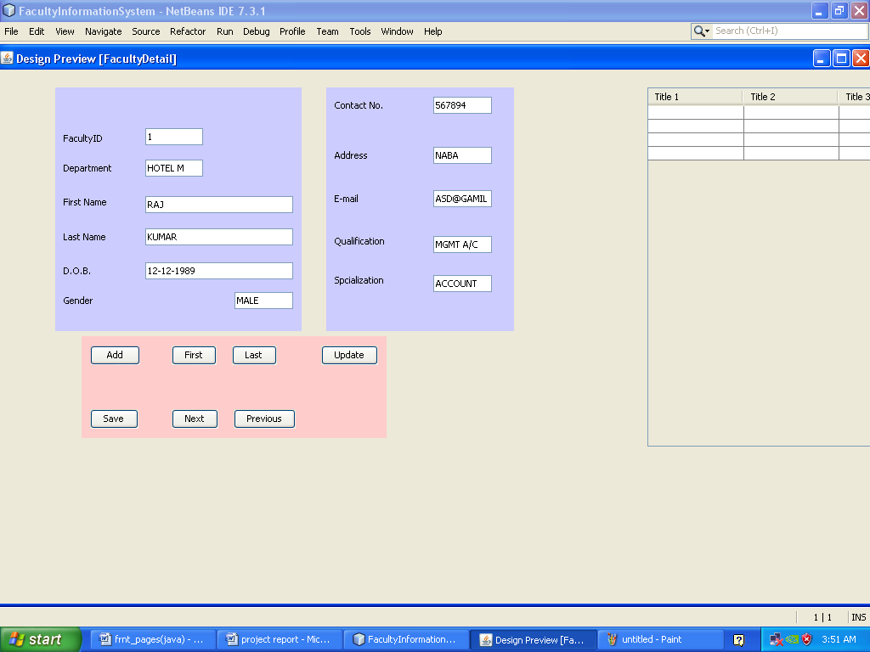

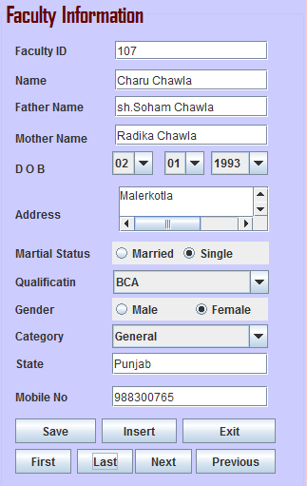

**Description:** It shows the last record of faculty info. When admin wants to see last record of faculty, then admin can click to the Last button and shows the Last record of table.

**Next Record:** 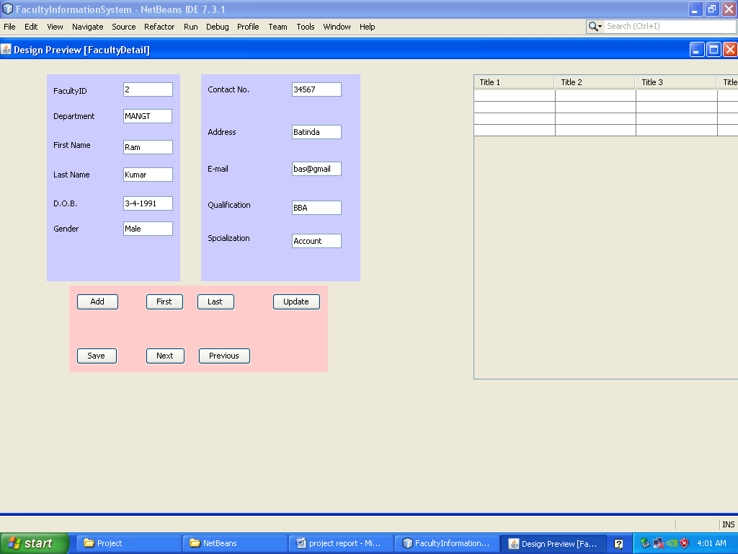

**Description:** When the admin can show the next record of faculty. Then, they can simply click on the next button and show the next record of the faculty.

**Previous Record**: 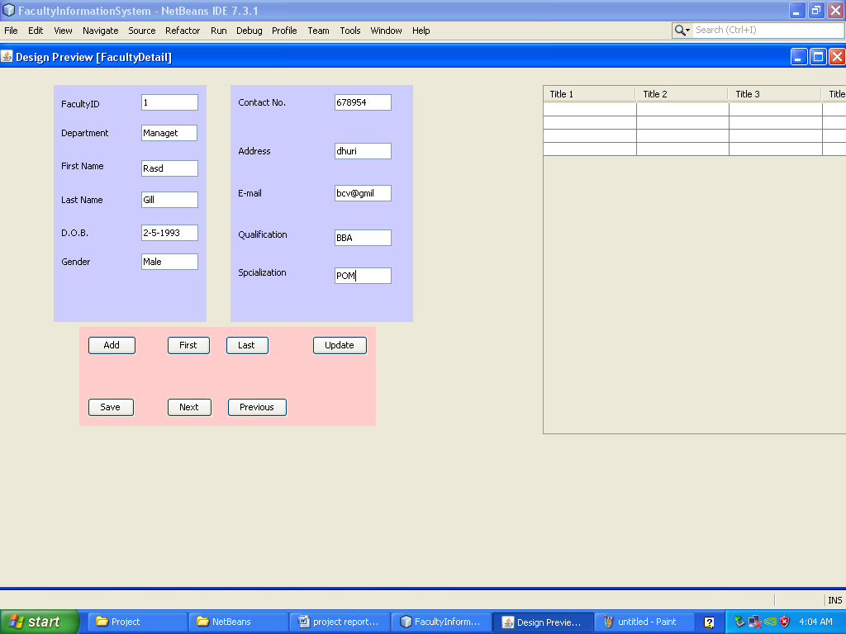

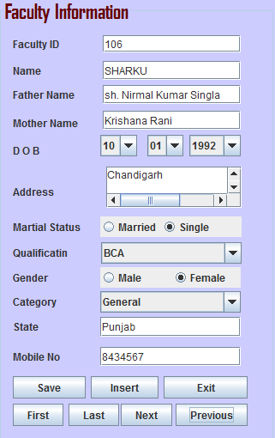

**Description**: When the admin can show the previous record of faculty. Then, they can simply click on the previous button and show the previous record of the faculty.

**Description**: In this, there a sub menu of profile that is HOME. when we click on home then we can directly go to Faculty information window (Main window) of the project.